**Wireshark Lab – TCP**

**Q # 1**

IP address : 192.168.1.2

Source Port: 3444

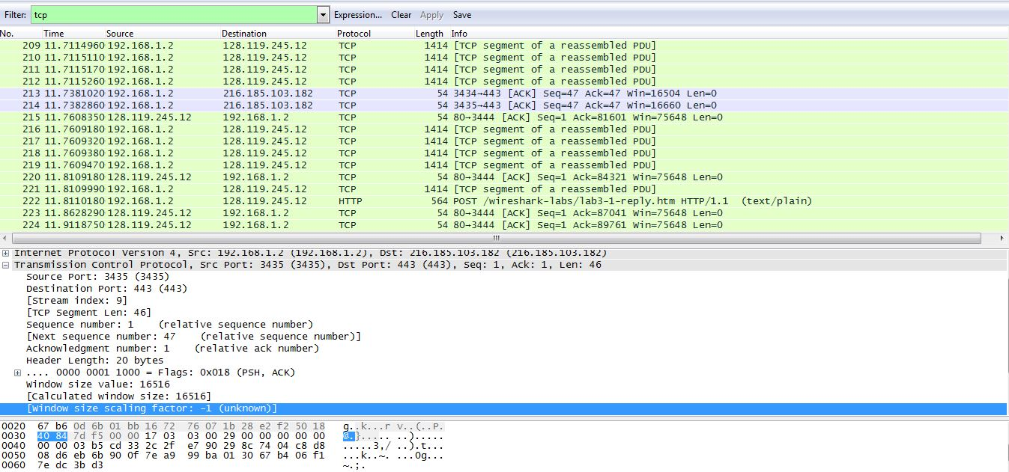

Q # 2

IP address: 128.119.245.12

Source Port: 80

Q # 3

Sequence no is 0

Value of flag = 0x002 is for SYN

Q # 4

Sequence no. is 0

ACK no. is 1

Value of flag = 0x012 is for SYNACK

Q # 5

Sequence No. is 1

Q # 6

Sequence no. are 1 , 1361 , 2721, 4081, 5441 , 6801

RTT for 1st segment is 0.244976sec

RTT for 2nd segment is 0.35927sec

Estimated RTT = 0.875 x Estimated RTT + 0.125 x Sample RTT

The value of estimated RTT for 3rd segment is = 0.2592575sec

Actual RTT for 3rd segment is 0.024939sec

The value of estimated RTT for 4th segment is = 0.23020sec

Actual RTT for 4th segment is 0.357851sec

Similarly, for 5th and 6th segments.

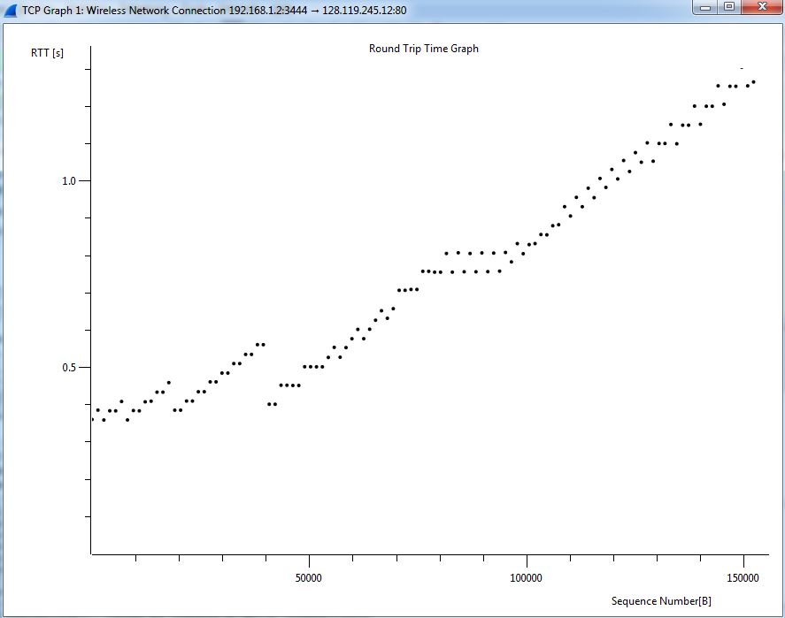

Q # 7

Length for first 6 segments is 1360 bytes

Q # 8

Q # 9

No there are no retransmissions

Q # 10

ACK is acknowledging 2944 bytes

In scenario when in-order segment with expected sequence number arrives then receiver is ACKing every other segment.

Q # 11

Throughput is 8411 bytes/sec

Data ACK per RTT / time for 1RTT = throughput

Q # 12

